

AuScope Discovery Portal User Guide

AuScope PTy Ltd.  |  email: cg-admin#csiro.au | [www.auscope.org.au](http://www.auscope.org.au) | December 2023

AuScope Discovery Portal User Guide

Contents

Table of Figures 2

Overview 3

Data Services 4

Map 5

Filter Panel 6

Wildcards 7

Download Panel 9

Selecting a bounding box to limit the download size 10

Custom layers 12

Custom URL 12

Custom File 13

Data Search 14

Map Navigation 16

Split View 17

Map Projection 18

Changing the default ESRI World Imagery base map 18

Search and Download Bar 20

Permanent Link 21

Login 22

Logout 23

Example 1: NVCL Boreholes 24

NVCL Boreholes: Steps 1,2,3 & 4 25

NVCL Boreholes: Step 5 26

NVCL Boreholes: Step 6 26

NVCL Boreholes: Step 7 27

NVCL Borehole Service View 27

NVCL Boreholes: Steps 8 & 9 29

Example 2: Download an NVCL TSG Dataset 31

Example 3: Filter By Geological Province 33

Steps 1 & 2: Filtering by name, add geological province layer 33

Step 5: Add NVCL borehole layer 35

Glossary 36

# Table of Figures

[Figure 1: Auscope Discovery Portal with ESRI National Geographic base map. 3](https://csiroau-my.sharepoint.com/personal/faz014_csiro_au/Documents/Desktop/AuScopeUserGuide.docx#_Toc153817680)

Figure 2: Map Layer controls 5

Figure 3: Map of Austrralia with default “ESRI Workd Imagery” base map. 5

Figure 4: Filter Panel 6

[Figure 5: Info Panel 8](https://csiroau-my.sharepoint.com/personal/faz014_csiro_au/Documents/Desktop/AuScopeUserGuide.docx#_Toc153817684)

[Figure 6: Two different kinds of download Panel 9](https://csiroau-my.sharepoint.com/personal/faz014_csiro_au/Documents/Desktop/AuScopeUserGuide.docx#_Toc153817685)

[Figure 7: Selecting a bounding box 10](https://csiroau-my.sharepoint.com/personal/faz014_csiro_au/Documents/Desktop/AuScopeUserGuide.docx#_Toc153817686)

[Figure 8: Download Panel with bounding box filter 11](https://csiroau-my.sharepoint.com/personal/faz014_csiro_au/Documents/Desktop/AuScopeUserGuide.docx#_Toc153817687)

[Figure 9: Custom layers 12](https://csiroau-my.sharepoint.com/personal/faz014_csiro_au/Documents/Desktop/AuScopeUserGuide.docx#_Toc153817688)

Figure 10: Load a KML or KMZ file onto map 13

Figure 11: Data search options 14

Figure 12: Using the magnify button to zoom to a certain area on the map (ESRI National Geographic) 16

Figure 13: Comparing borehole layers using the split view and the “Left”, “Right” and “Both” buttons 17

Figure 14: Selecting map projection 18

[Figure 15: Background map selection 18](https://csiroau-my.sharepoint.com/personal/faz014_csiro_au/Documents/Desktop/AuScopeUserGuide.docx#_Toc153817694)

Figure 16: Polygon Filter 19

Figure 17: The location of the login button 22

Figure 18: layers can be bookmarked 23

[Figure 19: Example core sample 24](https://csiroau-my.sharepoint.com/personal/faz014_csiro_au/Documents/Desktop/AuScopeUserGuide.docx#_Toc153817698)

Figure 20: NVCL Boreholes: Steps 1,2,3 & 4 25

Figure 21: NVCL Boreholes: Step 5 26

Figure 22: NVCL Boreholes: Step 6 26

Figure 23: NVCL Boreholes: Step 7 27

[Figure 24: NVCL Borehole Service View 27](https://csiroau-my.sharepoint.com/personal/faz014_csiro_au/Documents/Desktop/AuScopeUserGuide.docx#_Toc153817703)

Figure 25: NVCL Borehole Service detailed image and spectral data plots 28

[Figure 26: NVCL Boreholes: Steps 8 & 9 29](https://csiroau-my.sharepoint.com/personal/faz014_csiro_au/Documents/Desktop/AuScopeUserGuide.docx#_Toc153817705)

Figure 27: Depth and sample count at a point 29

Figure 28: NVCL Boreholes: Graph of borehole minerals 30

Figure 29: NVCL Boreholes: Details of graph controls 30

[Figure 30: Click on "Add Layer" 31](https://csiroau-my.sharepoint.com/personal/faz014_csiro_au/Documents/Desktop/AuScopeUserGuide.docx#_Toc153817709)

[Figure 31: Click on Prepare Tsg Dataset button 32](https://csiroau-my.sharepoint.com/personal/faz014_csiro_au/Documents/Desktop/AuScopeUserGuide.docx#_Toc153817710)

[Figure 32: Step 1 & step 2, filter by geological province 33](https://csiroau-my.sharepoint.com/personal/faz014_csiro_au/Documents/Desktop/AuScopeUserGuide.docx#_Toc153817711)

[Figure 33: Steps 3 & 4, Filter by geological province 34](https://csiroau-my.sharepoint.com/personal/faz014_csiro_au/Documents/Desktop/AuScopeUserGuide.docx#_Toc153817712)

Figure 34: Step 5, filter by geological province 35

# Overview

The AuScope Discovery Portal <https://portal.auscope.org.au/> displays geospatial data obtained from a number of geoscience organisations around Australia. The portal provides a way to find and download geospatial data and display it on the map. Finding the data is managed by the *data services* panels at the left hand side; and the new search bar at the top.

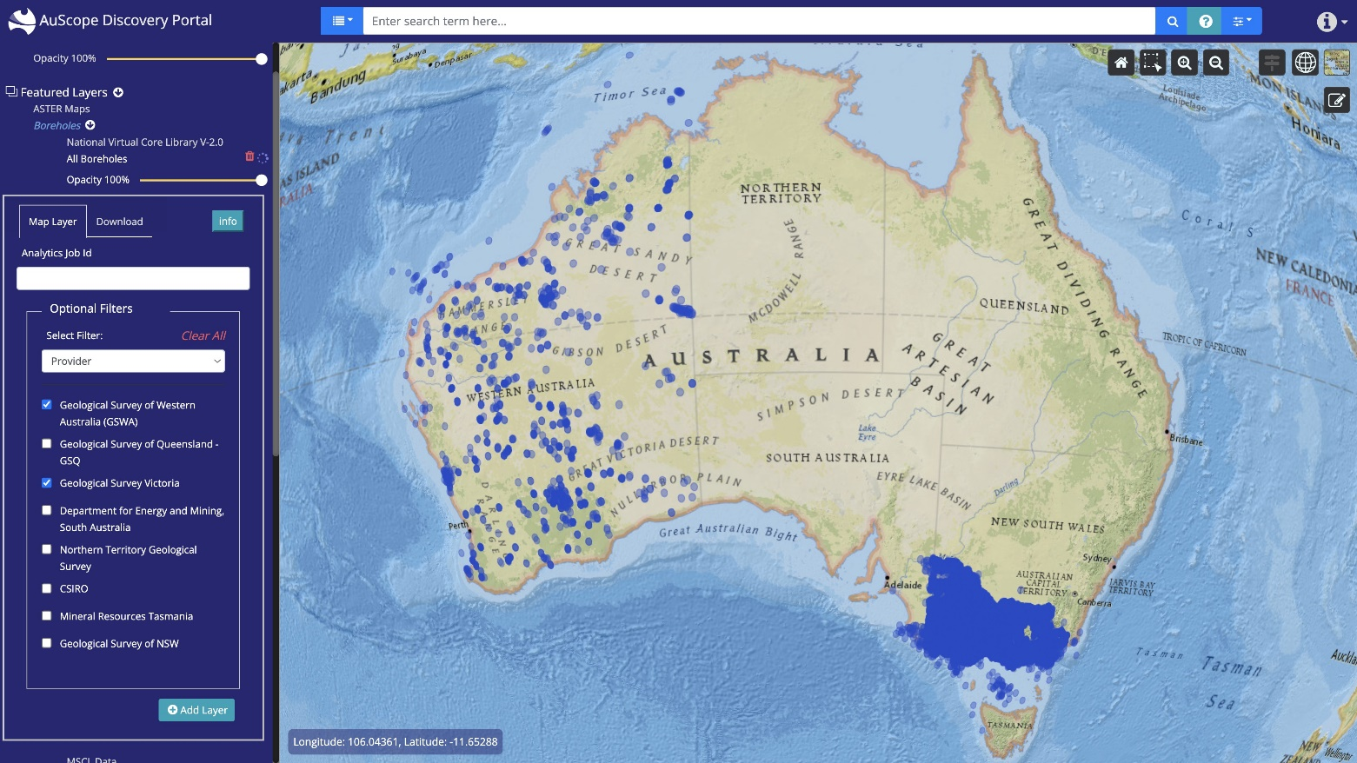The following sections describe the portal: the first section of this document is an overview of the portal. Later sections provide details on the portal's operations. The examples section contains steps to perform common activities.

Figure : Auscope Discovery Portal with ESRI National Geographic base map.

# Data Services

The data services are a collection of web-based services from organisations around Australia that provide geospatial data, such as Geoscience Australia, CSIRO, state governments geological surveys and several Australian universities.

Various organisations provide data to the portal: it may be as simple as satellite imagery or a view into a geospatial database. The data provided by these services are drawn as *layers* overlaying the background map. Selecting the data to view is managed by the panel to the left hand side of the window.

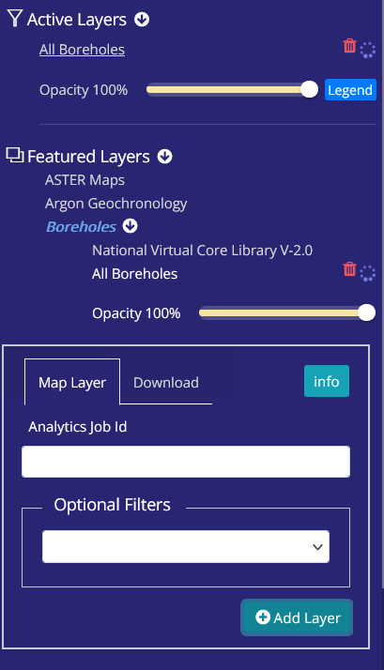

Displays layer metadata in the Info Panel

Layer opacity slider control

Click here to dlsplay layer legend

Click here for layer status report

Click to remove layer from map

Layer Name

Layer group. Click to open list of layers

Click to open list of layer groups

Layer loading indicator

Click to open list of layers

Figure : Map Layer controls

#### To view a layer you have to:

1. Select a layer from one of the lists, by clicking on the layer category, then the layer name
2. Select the "Filter" panel by clicking on the its tab
3. Optionally filter the data (for example, a specific mineral type); and
4. Add the data as a map layer by clicking on **Add Layer** button in "Filter" panel

Note that adding a layer may not display the data immediately: the data has to be fetched from the providers and so it may take a few minutes and be displayed in batches.

# Map

The map area is a standard web-based map display: showing a background map with zero or more layers overlaying the map to display selected features. You can zoom in or out by using the mouse wheel and move the map by dragging the mouse around.

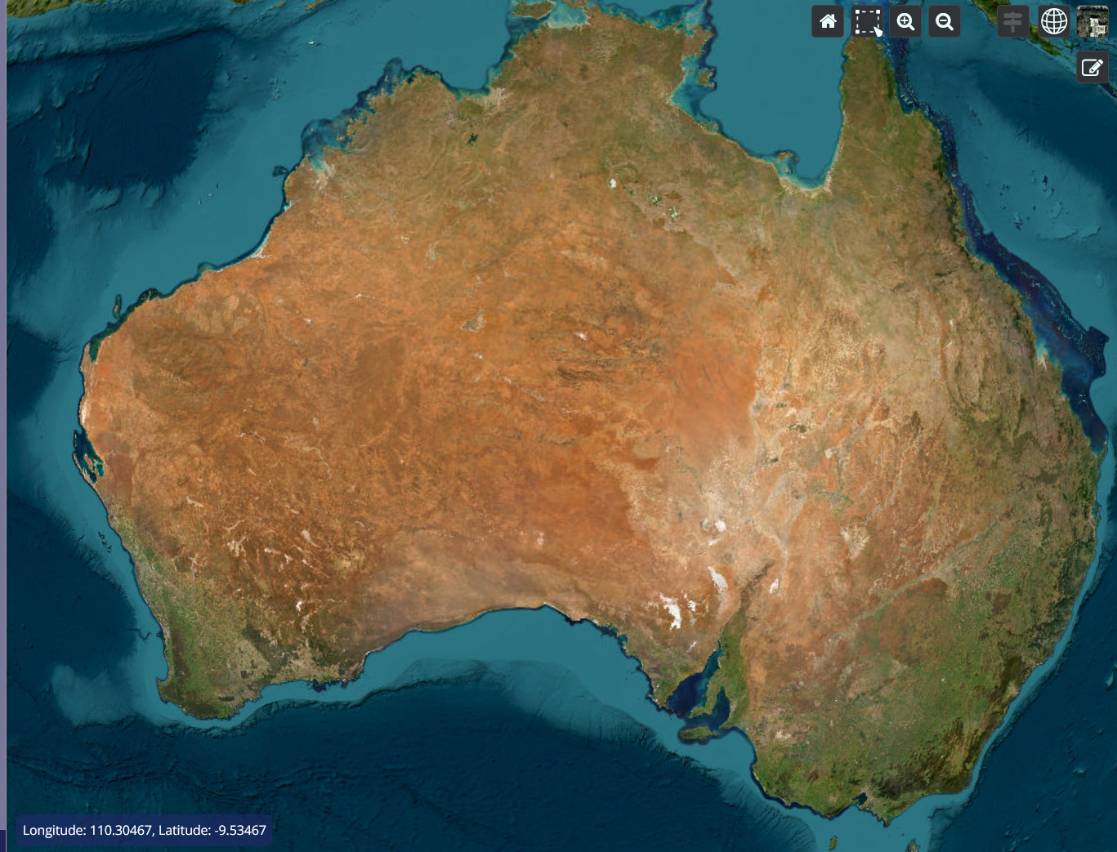

Figure : Map of Austrralia with default “ESRI Workd Imagery” base map.

# Filter Panel

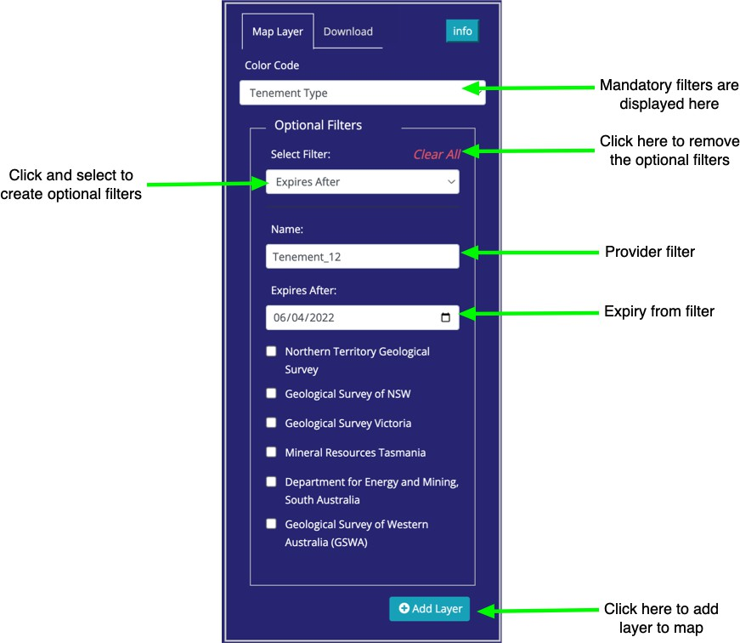

Figure : Filter Panel

Each layer provides different ways to filter the data depending on the structure its data. The following image shows a sample of the filters from three different mining layers. Note that each filter provides fields of several types: plain text, dates and select lists.

 Plain text fields match the data exactly, but case insensitive. Some data services also support wildcards to match portions of the field.

 Date fields are in the format: yyyy-mm-dd and also provide a pop-up calendar to selected the date (invalid dates are indicated with a red border around the input text box).

 Select lists are populated from unique values from the data.

Some layers may not have any filters. Layers that supply imagery may only provide a filter to change the layer's opacity when the images are drawn on the map.

Some layer fields are numeric, for example the amount of ore processed. There are no checks to verify that you have entered a numeric value in these fields. Entering non-numeric will result in either no data or the filter will be ignored.

Click the **Add layer to map** button to apply any filters to the data and display the results on the map. If the layer is already active it will be replaced by a layer with the new filter.

A number of data services provide data from external sources and when they are added to the map a copyright notice will be show.

### Wildcards

Wildcards are special characters that allow filters to match all or part of a text field. They may also position the match at the beginning or end of the field.



A data provider may choose not to implement wildcards (for example, to reduce processing overheads) or limit their behaviour. This means a filter on a text field *may* accept any of these matching rules:

1. A strict match of the entire text field, usually case insensitive.
2. A match to any portion of the field. For example a filter of "old" will match "goldfield lease" and "the folding chair".
3. A "match any" beginning/end wildcard (asterisk: **). For example "sil**" will match "silver mine" and "silicon chip". Similarly "*ts" will match "hot spots" and "polar orbits"
4. A "single character" wildcard (Hash: #). For example "*9#" will match "bore 295" and "mine number 1294"

**Info Panel**

Clicking on the "info" button to open up the information panel to find more detailed information about the layer. Click on the provider name to display service details.

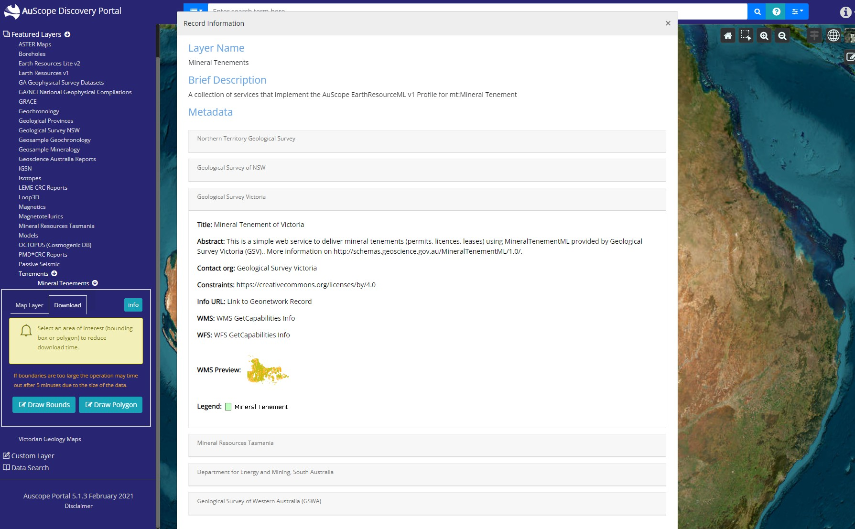

Figure : Info Panel

# Download Panel

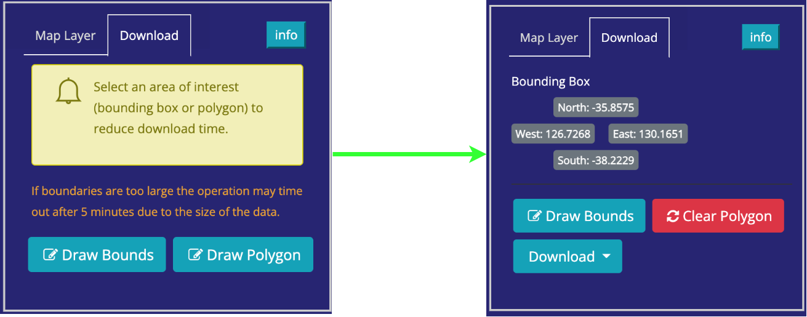

Figure : Two different kinds of download Panel

If you would like to perform further analysis on the data being viewed in the portal you can download the data to your workstation by selecting the **Download**

Tab.

If you click on the **Download** button, you will download all the data from all providers. This request may fail if there is too much data, as the connection may time out.

It is therefore advisable to use the **Draw Bounds** or **Draw Polygon** (if available) buttons to reduce the size of the download request.

## Selecting a bounding box to limit the download size

Figure : Selecting a bounding box

If you click on the **Draw Bounds** button you can create a bounding box by clicking twice in the map area, once in the top left corner and again in the bottom right corner as shown above. Some layers will provide a **Draw Polygon** button that will allow you to draw a polygon to define download bounds.

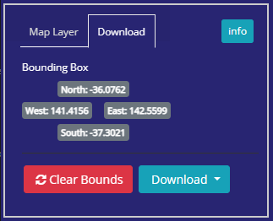

Figure : Download Panel with bounding box filter

Once a bounding box has been defined, the Download Panel will display its coordinates (above), and you can click on the **Download** button to get the results.

# Custom layers

## Custom URL

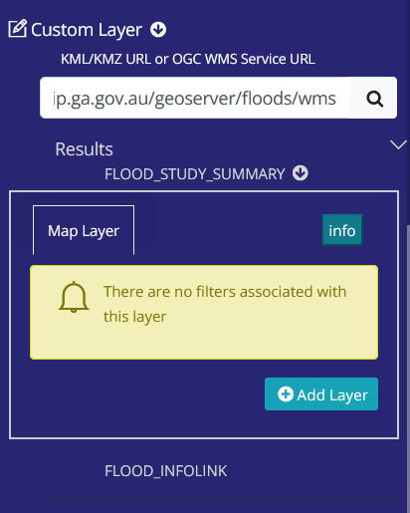

Figure : Custom layers

Custom Layers allow you to add layers from any mapping server in the world. You will need the link (URL) to the web service and enter it into the field in the panel:

Press **Enter** or click on the **magnifying glass **to connect to the service and the portal will query the service's capabilities. In the above figure a flood map provides precipitation and cloud maps amongst other weather data. These capabilities are treated like normal map layer and can be added to the map by clicking on the layer name and clicking the **Add layer to map** button.

|  |  |  |
| --- | --- | --- |
| **Type of data** | **Source Type** | **URL** |
| Flood reports | WMS | [https://afrip.ga.gov.au/geoserver/floods/wms](https://afrip.ga.gov.au/geoserver/floods/wms?request=GetCapabilities&version=1.3.0) |
| WA bike trail | KML | <https://catalogue.data.wa.gov.au/dataset/f950141e-f484-4edd-b6d3-2ead49a4a476/resource/553e646a-0bff-406f-8c45-85c733642f0f/download/munda_biddi_cycle_trail.kml> |
| Power liines | KMZ | <https://d28rz98at9flks.cloudfront.net/83105/ElectricityTransmissionLines_v2.kmz> |

## Custom File

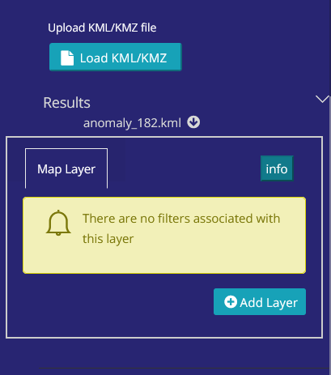

Figure : Load a KML or KMZ file onto map

The user can also load a custom KML or KMZ file onto the map, by clicking on the “Load KML/KMZ” button selecting a file, then adding the layer as described in the previous section.

# Data Search

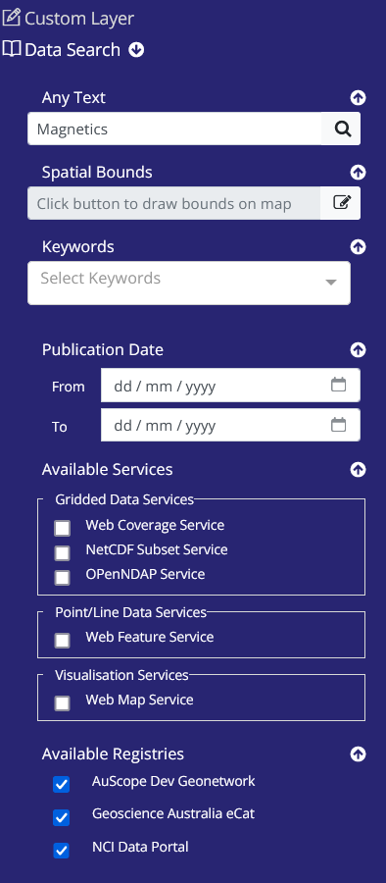

Figure : Data search options

Data Search can be accessed under the “Custom Layers”.

This enables you to search catalogues for datasets to display on the portal’s map.  
  
There are many options to use in your search.

* Text search
* Spatial Bounds
* Keywords
* Publication Date Range
* Service Type
* Registry

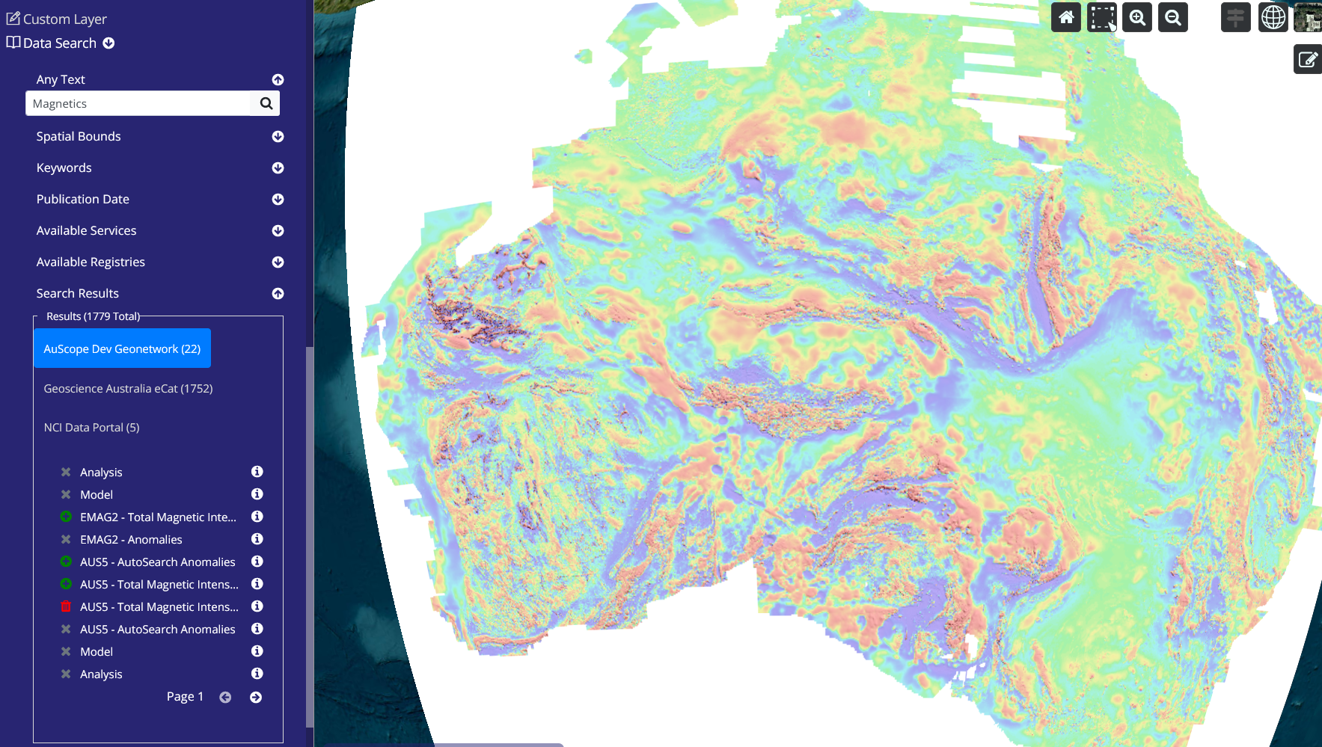

A search is commenced by clicking on   
  
A list of layers is generated. If you click on  the layer can be loaded on the map.  
The layer can be removed via  button.  
Clicking on  opens up an information panel with a map of the area covered by the dataset marked in blue, if it is available from the catalogue.

# Map Navigation

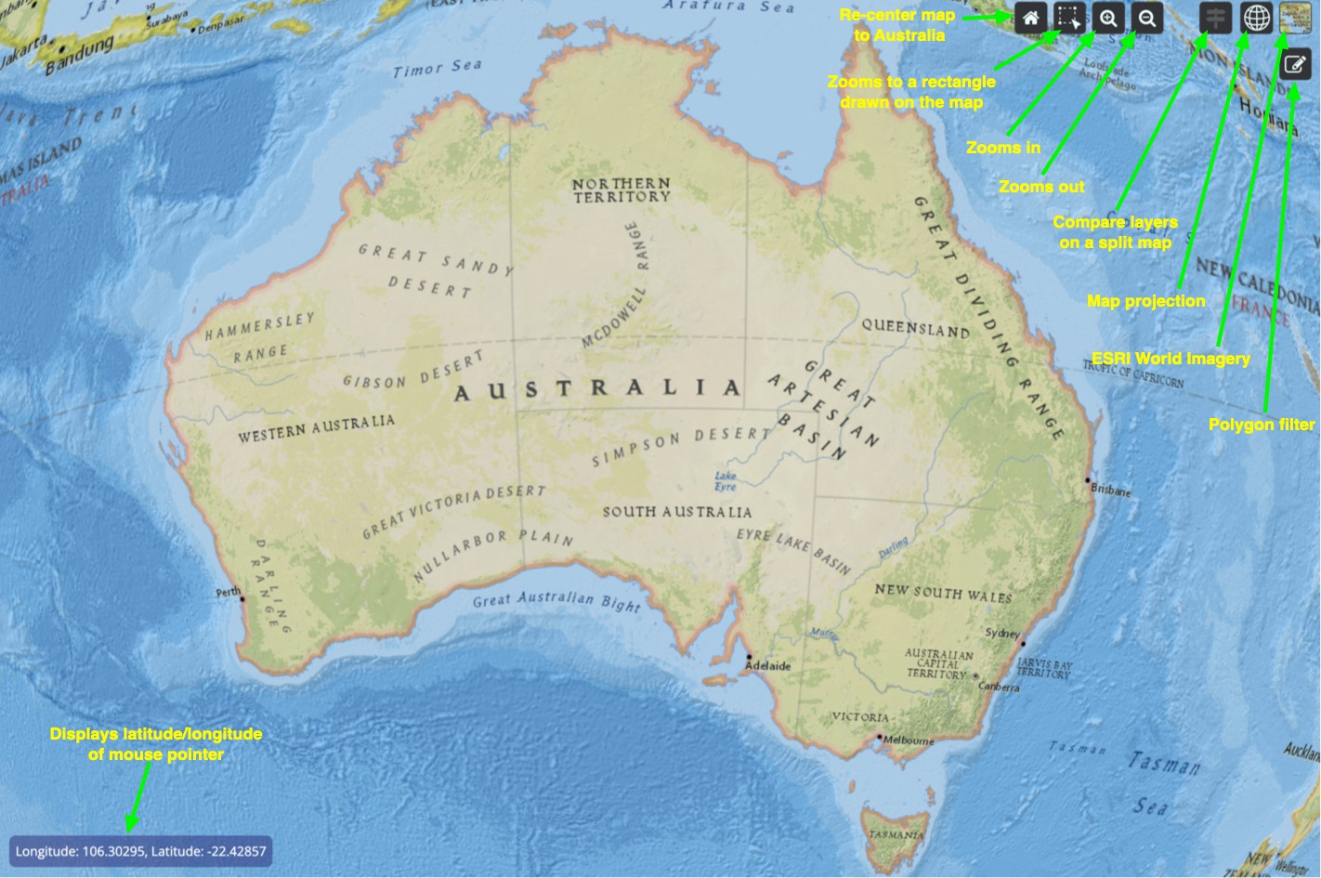

Figure : Using the magnify button to zoom to a certain area on the map (ESRI National Geographic)

There are several ways to navigate around the map.

 Using the Zoom button, click the **plus +** or **minus -** signs to zoom in or out.

 **Magnify** button can be used to zoom to a particular area on the map:

1. Click **Magnify**
2. Click at the top left hand corner
3. Click at the bottom right hand corner

 Using the mouse:

 Move the map: hold the left-mouse button down and move the mouse.  Zoom in and out: use the mouse's scroll wheel.

## Split View

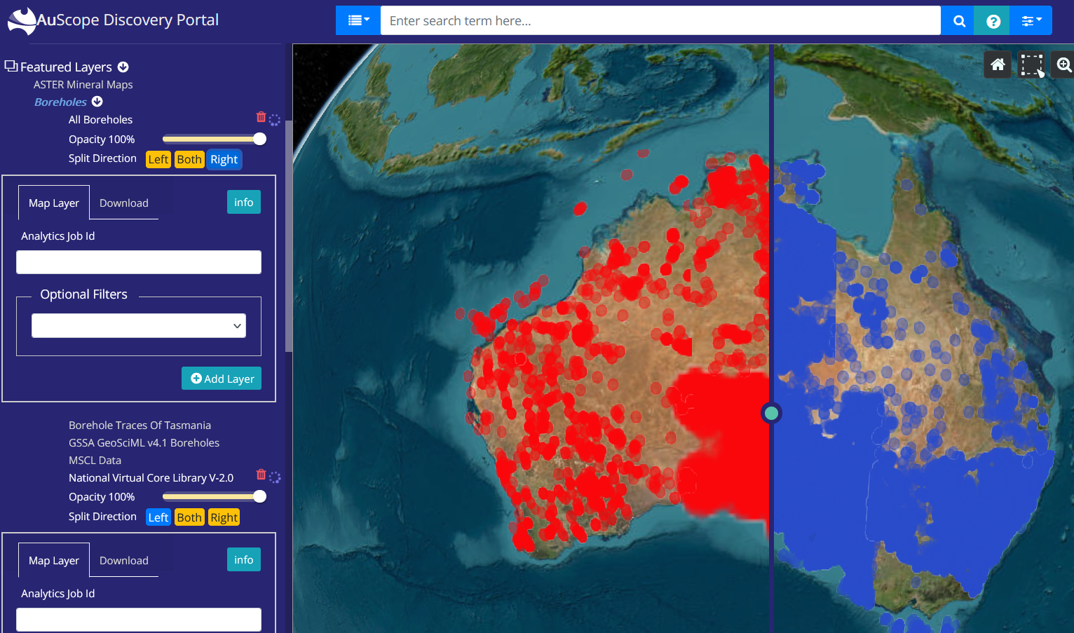

Figure : Comparing borehole layers using the split view and the “Left”, “Right” and “Both” buttons

Once split view mode is enabled via this button, you can load two layers into the “Left”, “Right” or “Both” sides of the map by toggling the buttons.

## Map Projection

Using the map projection button you can select:

 2D

 3D

Columbus View





Figure : Selecting map projection

## Changing the default ESRI World Imagery base map

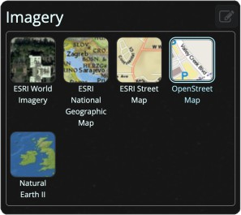

Figure : Background map selection

There are a number of base maps to choose from by clicking on the button in the far top right corner of the map.

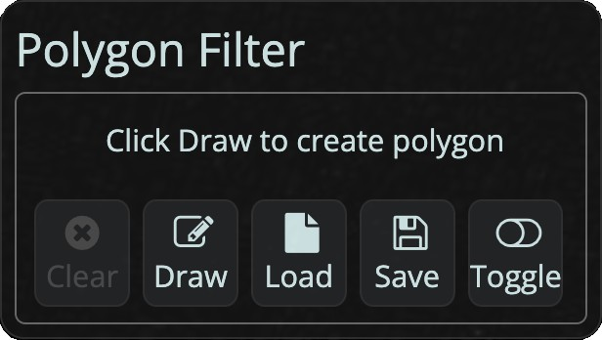

Figure : Polygon Filter

The polygon filter is used as a map filter when selecting an area of the map from which to download data, for example.

# Search and Download Bar

Use the search bar at the top of the page to search for specific layers.

Enter a search term in the text field provided and press the search button  to conduct the search. You may also choose from one of the suggested terms as you type by clicking on it.

Press the Advanced Options button  to show the Advanced Option toolbar, which allow you to further refine your search to specific record fields, OGCS services and spatial locations.

Results may automatically be hidden as you interact with the map, to reveal them again press the show/hide results button .

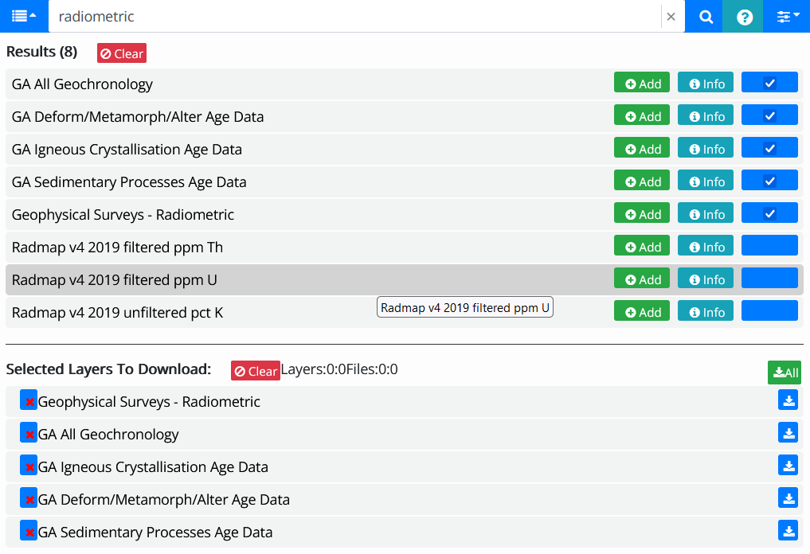

If you click on the  then a “Select Layers to Download” section will open up and you can select layers’ datasets for downloading . They are downloaded via the  button. Multiple layers can be downloaded using the  button.

# Permanent Link

The current state of the portal can be captured in the form of a unique URL. The URL can be revisited at any time by entering it into your web browser. This is very useful, for example for sharing maps with others.

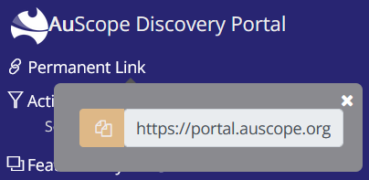

To activate, you click on “Permanent Link” at the top left hand corner. The URL will be generated. To copy it to the system clipboard click on the  button.

# Login

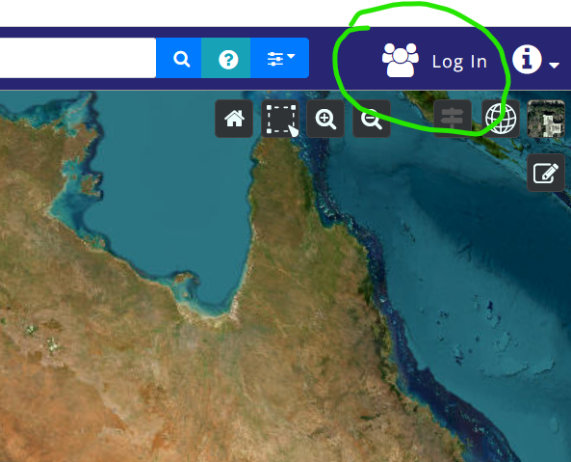

Figure : The location of the login button

You can also login to the portal via AAF or Google ot github by clicking on the login button shown above.

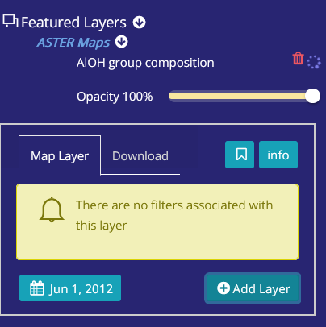

Figure : layers can be bookmarked

Once logged in, layers can be bookmarked for future reference using the  toggle button. Click on the button a second time to undo the layer bookmark. The bookmarked layers are kept for you and will still be there next time you login.

# Logout

Logout  can be selected via the  button on the top right hand corner of the page.

# Example 1: NVCL Boreholes

The National Virtual Core Library (NVCL) is a geospatial database holding high resolution pictures of drill samples to help explore the mineralogy and composition of the upper 1-2 km of the Australian continent. The drill samples in the library come from a number of sources including State agencies and industry.

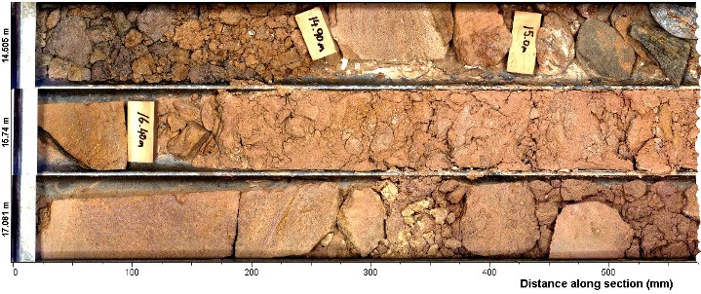

Figure : Example core sample

The following steps display the NVCL data on the portal's map and view the details for one of the core samples. Images of the each step are shown below.

1. Select **Boreholes** from the list.
2. Select the **National Virtual Core Library V2.0** from the list of layers.
3. Click on the **Add layer** button to draw the data points on the map. You may also filter the data to a subset using the options in the filter panel (remember to select the filters *before* adding the layer to the map).
4. Click on a coloured marker on the map, a popup dialog box will appear.
5. Click on borehole id to open up details panel.
6. Click on **Analytic** tab.
7. This shows thumbnail images of the borehole cores. Next, click on **Scalar** tab.
8. This shows all datasets obtained from measurements of the core samples. For example infra-red spectroscopy measurements of the samples. You can click on the "Definition" link to get more information about what kind of sample was taken. The next action is to select a dataset or more by clicking in the tickboxes.
9. Click on graph icon to display a graph of the selected mineral measurements.

## NVCL Boreholes: Steps 1,2,3 & 4

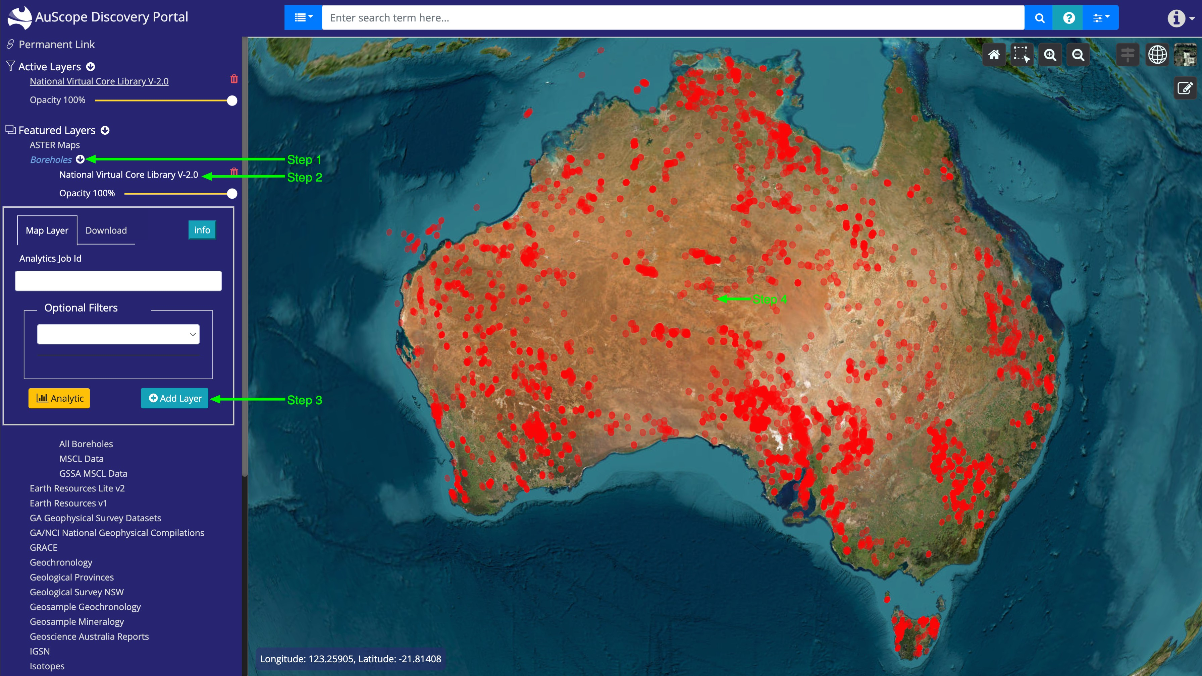

Figure : NVCL Boreholes: Steps 1,2,3 & 4

## NVCL Boreholes: Step 5

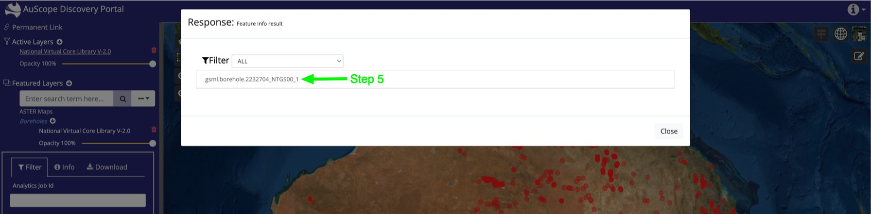

Figure : NVCL Boreholes: Step 5

## NVCL Boreholes: Step 6

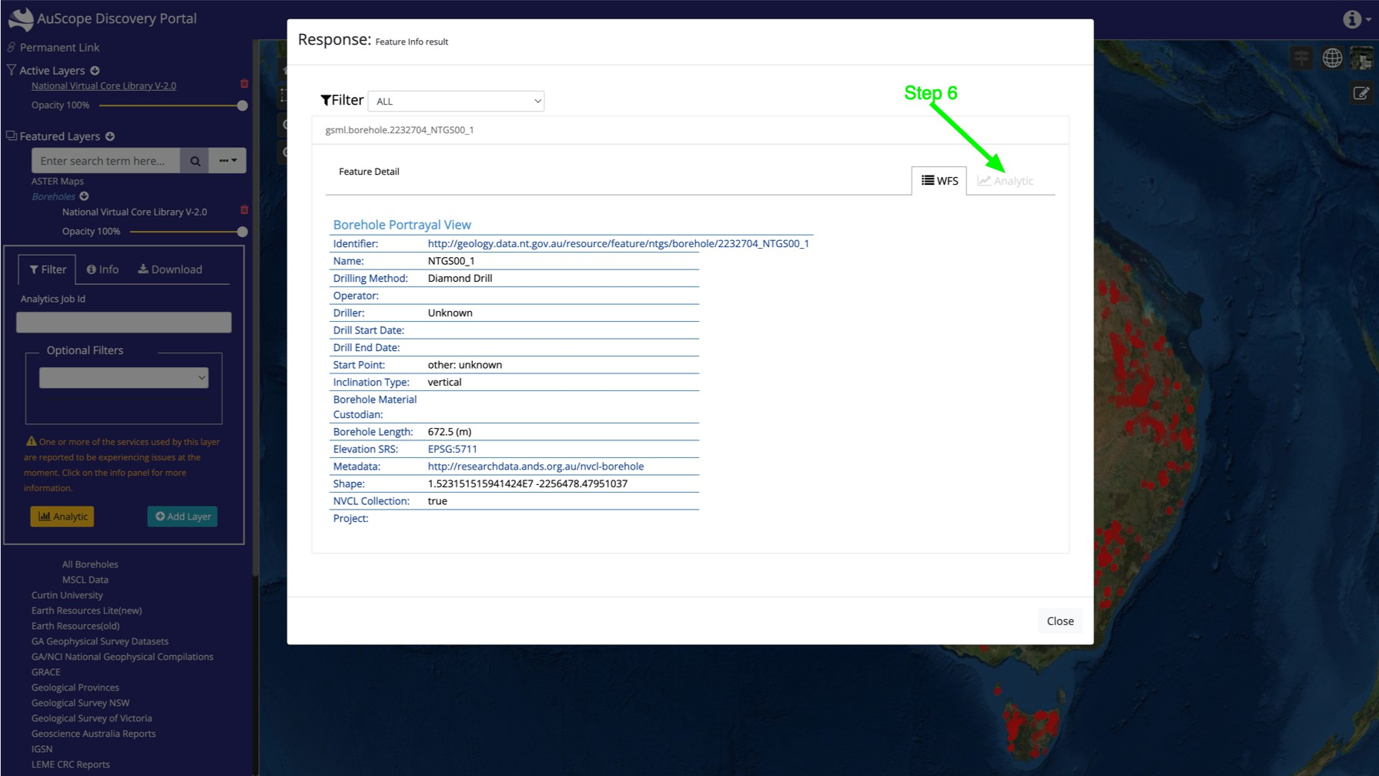

Figure : NVCL Boreholes: Step 6

## NVCL Boreholes: Step 7

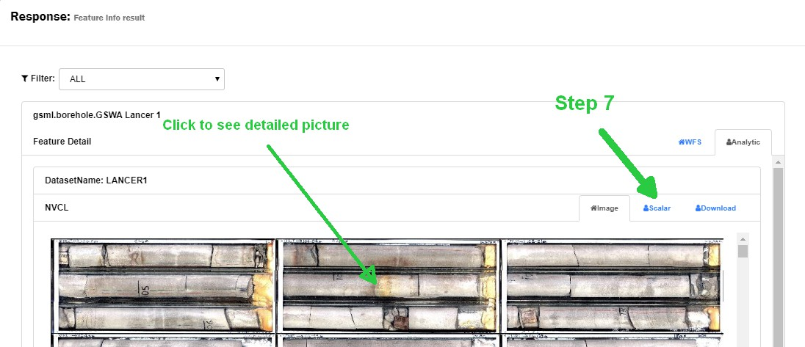

Figure : NVCL Boreholes: Step 7

## NVCL Borehole Service View

In Step 7 above, you can click on a thumbnail in the AuScope portal and get a high resolution image of the borehole drill samples from the relevant NVCL service website.

At the left and right hand side of the image there are arrows which can be used to view borehole images at lower and higher depths (see below).

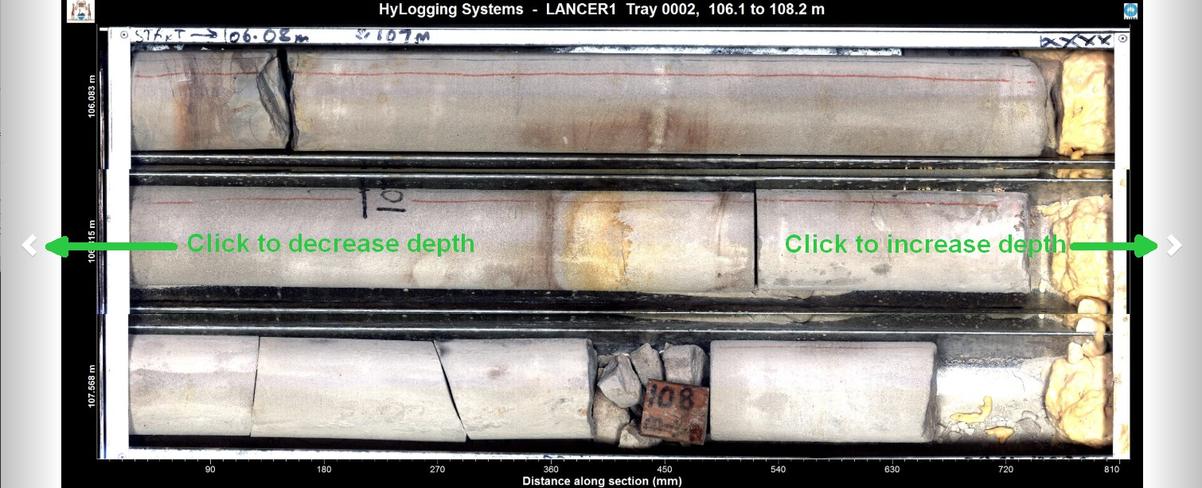

Figure : NVCL Borehole Service View

If you *double click* on this picture, you can see spectral data plots taken from the samples, as depicted below.

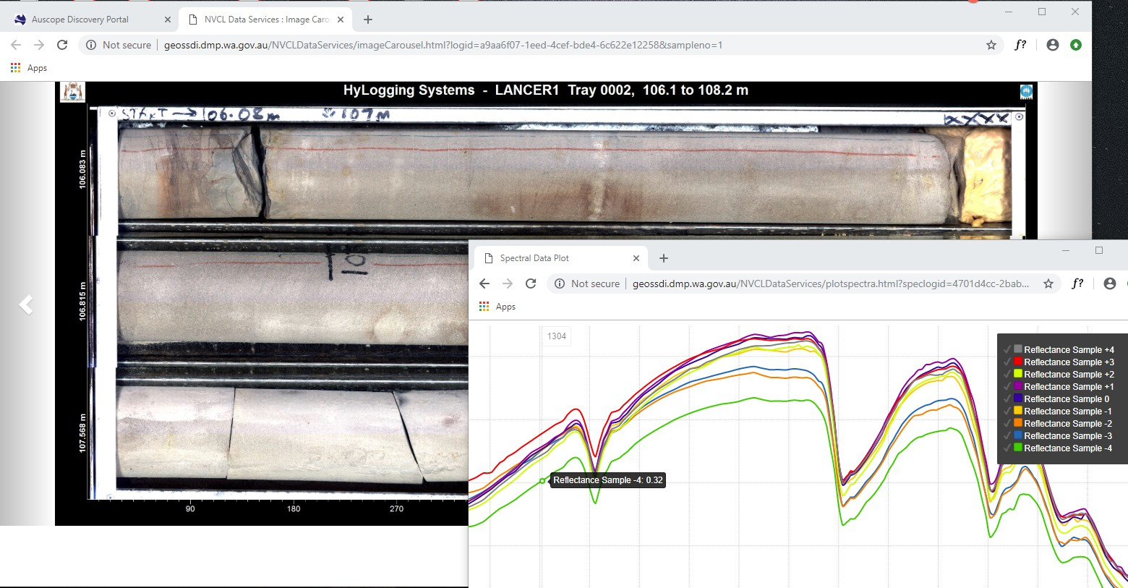

Figure : NVCL Borehole Service detailed image and spectral data plots

## NVCL Boreholes: Steps 8 & 9

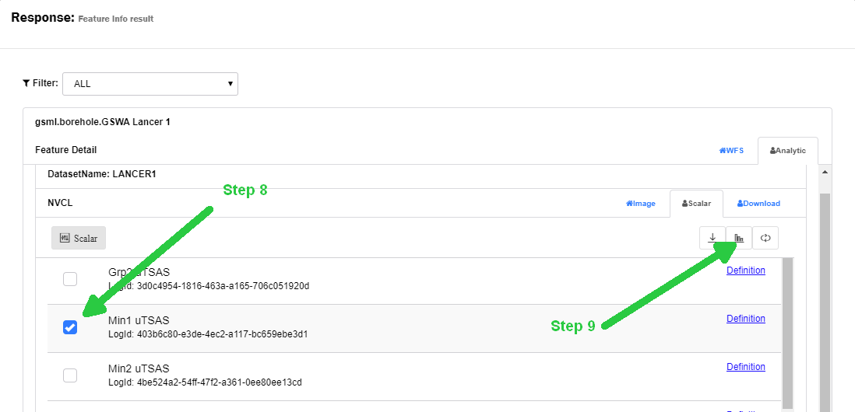

Figure : NVCL Boreholes: Steps 8 & 9

A typical graph of the mineral measurements is shown below. A user can hold the mouse pointer over a point in the graph and the depth and sample count at that point will be displayed, e.g.

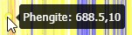

Figure : Depth and sample count at a point

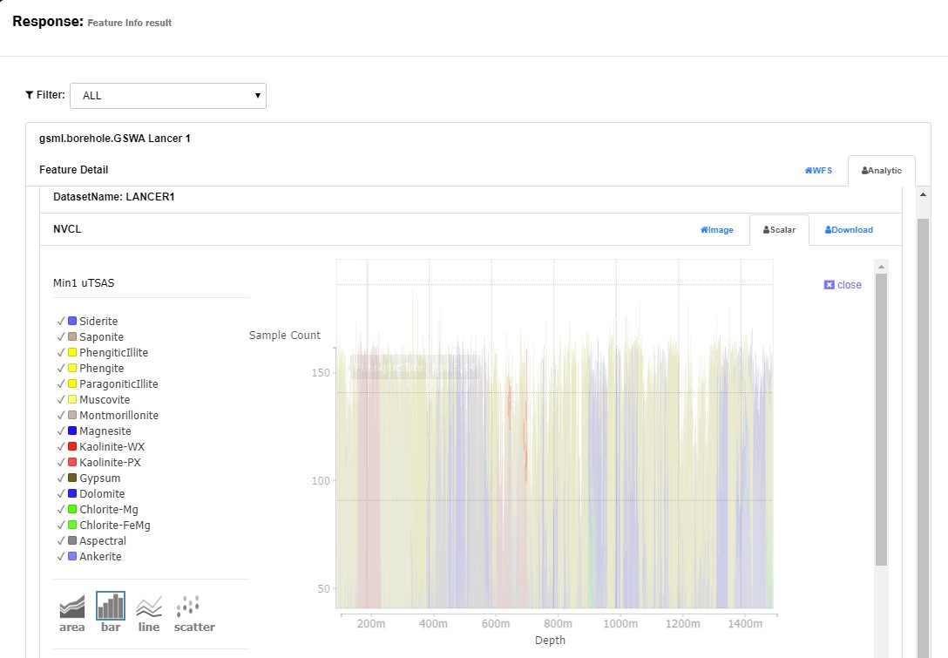

Figure : NVCL Boreholes: Graph of borehole minerals

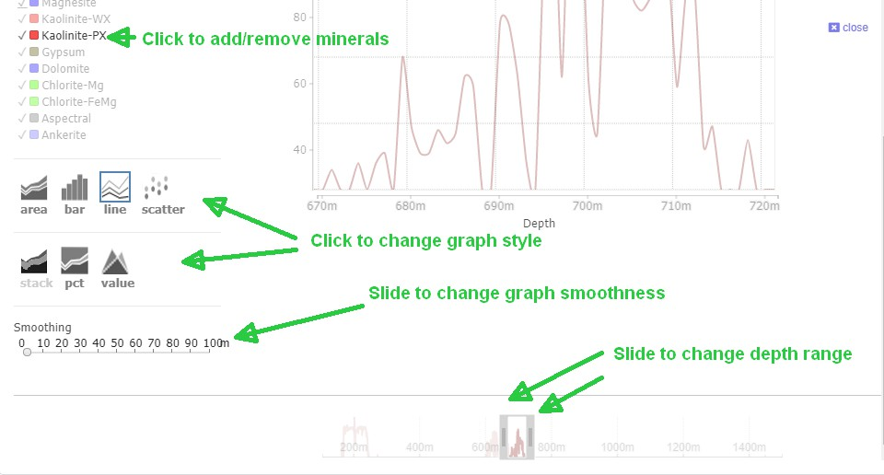

Figure : NVCL Boreholes: Details of graph controls

# Example 2: Download an NVCL TSG Dataset

To download an NVCL TSG Dataset:

1. Select **Boreholes** from the list.

Select the **National Virtual Core Library V2.0** from the list of layers.

Click the **Filter** tab.

Click on **Select Filter** dropdown and select **Name**.

Enter a name (e.g. Shittim).

Click **Select Filter** dropdown and select **Provider**.

Click on **Tasmania** (for example).

Click the blue **Add Layer** button to display boreholes on the map.

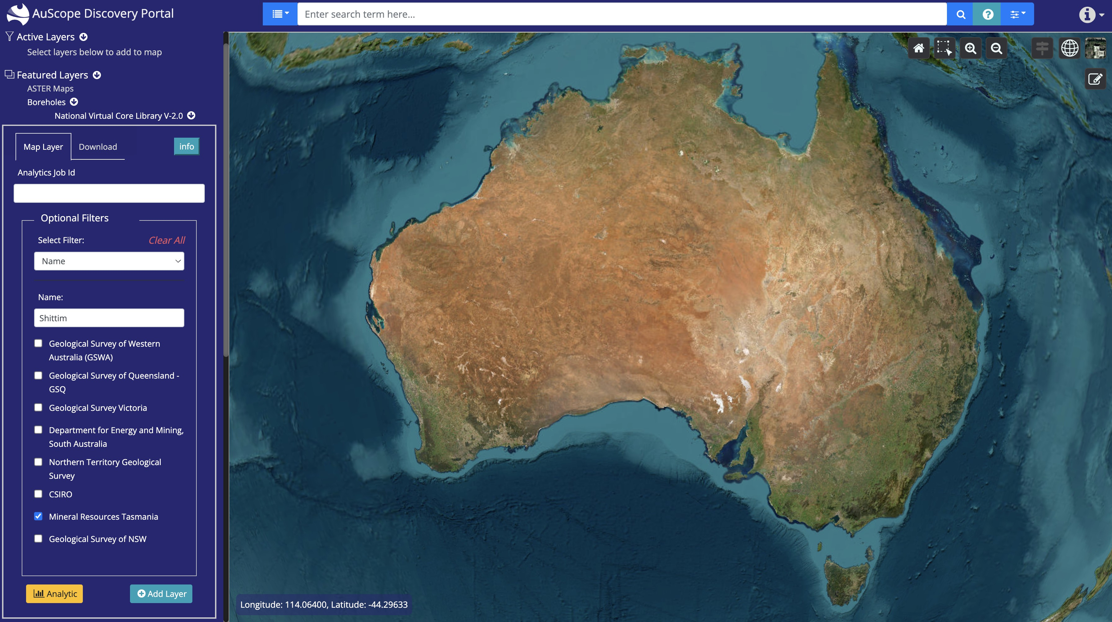

Figure : Click on "Add Layer"

1. Click a red borehole point on the map.

A popup window will open up.

Click on the grey borehole identifier.

Click the **Analytic** tab.

Click the **Download** tab.

Enter your email address.

Click on **Prepare Tsg Dataset** button.

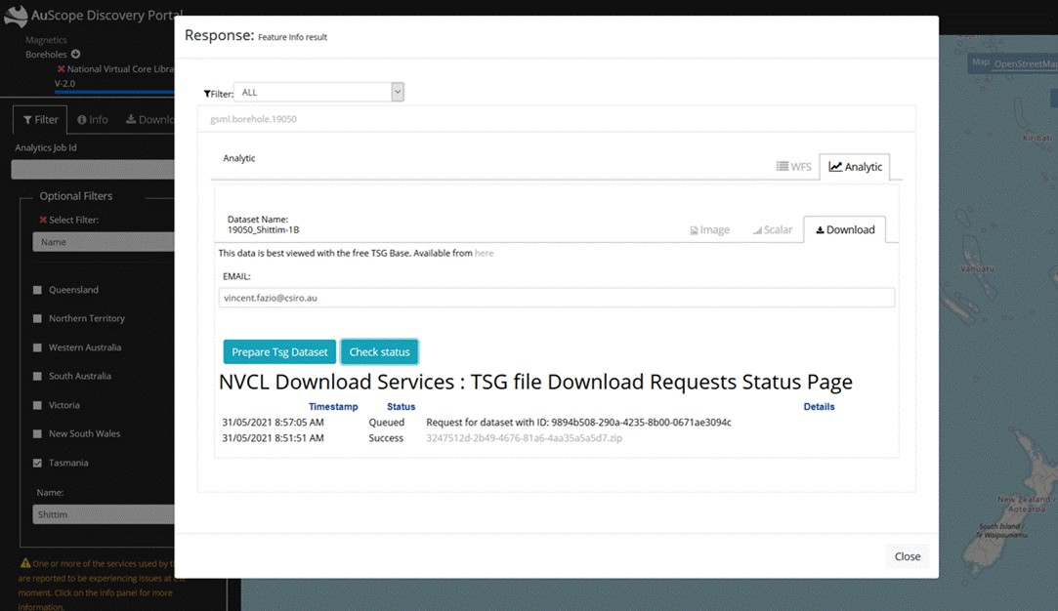

Figure : Click on Prepare Tsg Dataset button

# Example 3: Filter By Geological Province

## Steps 1 & 2: Filtering by name, add geological province layer

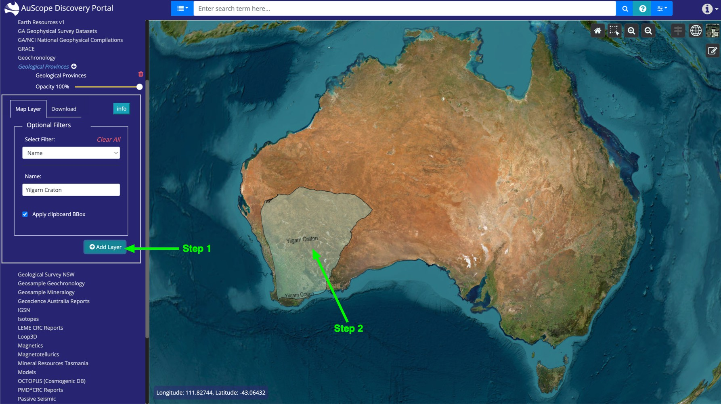

Figure : Step 1 & step 2, filter by geological province

Step 1: Filtering by name, add geological province layer

Step 2: Click on layer

Steps 3 & 4: Clicking on ‘gml:ProvinceFullExtent ...’ link

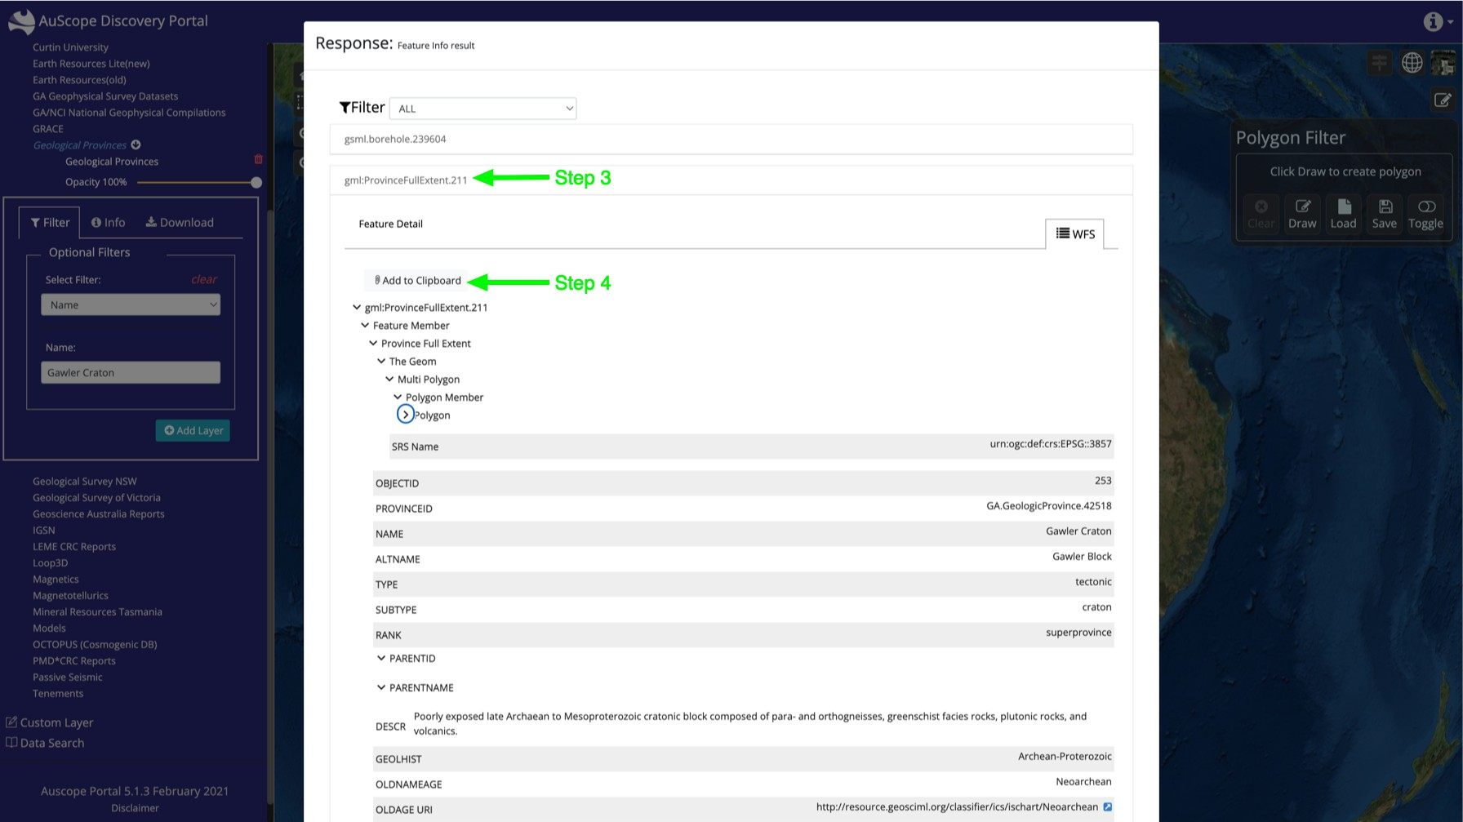

Figure : Steps 3 & 4, Filter by geological province

Step 3: Click on "gml:ProvinceFullExtent ..." link to reveal details as shown above

Step 4: Click on "Add to clipboard" button, close dialog box

## Step 5: Add NVCL borehole layer

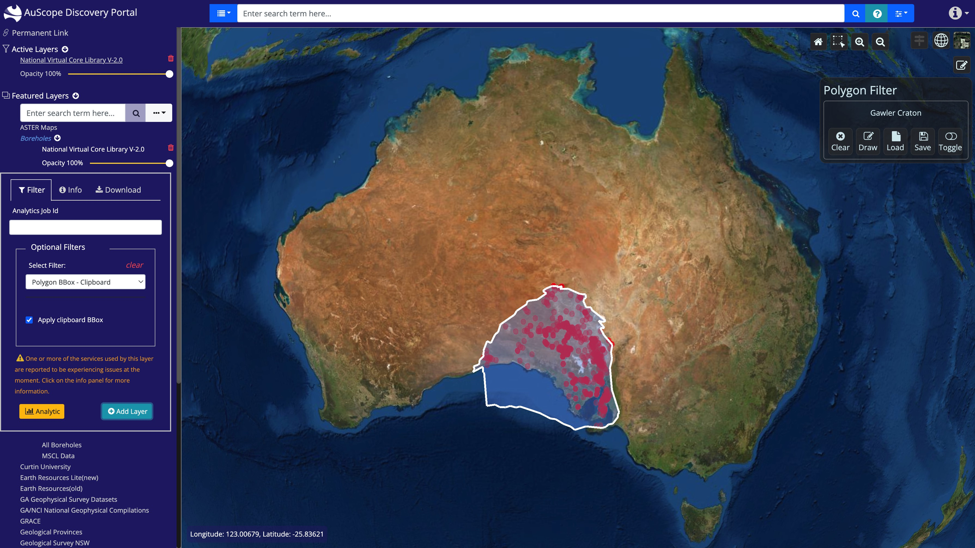

Figure : Step 5, filter by geological province

Step 5: Add NVCL borehole layer, using the "Polygon BBox" filter, making sure "Apply clipboard BBox" checkbox is ticked.

# Glossary

|  |  |
| --- | --- |
| **Term** | **Meaning** |
| [CSW](https://en.wikipedia.org/wiki/Catalog_Service_for_the_Web) | Catalog Service for the Web (Catalog Service – Web) |
| [GA](https://www.ga.gov.au/) | Geoscience Australia |
| [GML](https://en.wikipedia.org/wiki/Geography_Markup_Language) | Geography Markup Language |
| [OGC](https://en.wikipedia.org/wiki/Open_Geospatial_Consortium) | Open Geospatial Consortium |
| [SRS](https://en.wikipedia.org/wiki/Spatial_reference_system) | Spatial Reference System |
| [WCS](https://en.wikipedia.org/wiki/Web_Coverage_Service) | Web Coverage Service |
| [WFS](https://en.wikipedia.org/wiki/Web_Feature_Service) | Web Feature Service |
| [WMS](https://en.wikipedia.org/wiki/Web_Map_Service) | Web Mapping Service |
| [XML](https://en.wikipedia.org/wiki/Xml) | Extensible Markup Language |